Evidence of good collaboration

Good communication and file sharing
Receivable evidence includes:
- Emails and other types of messages (Facebook messenger, WhatsApp etc.)
- Screenshots of Basecamp conversations in which you actively participate.
- Screenshots showing files (designs, reports) that you shared with your team on Basecamp
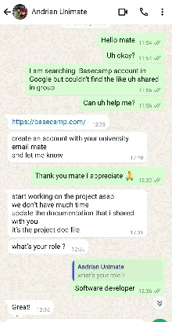
Important: Please include no more than 5 items
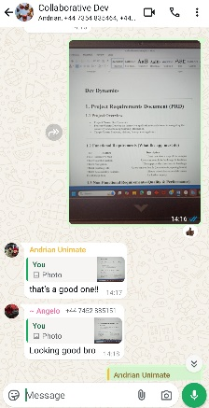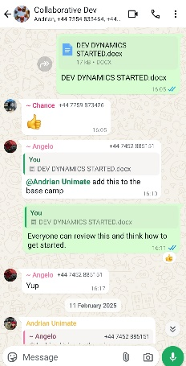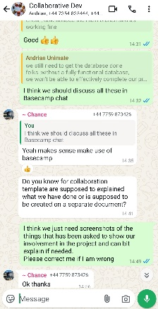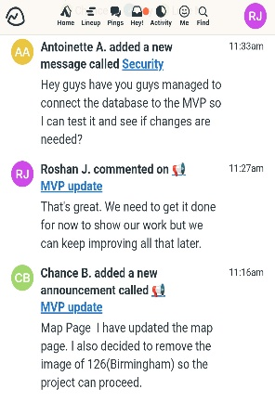
First picture: This is my first chat with my pm to create basecamp.
Second picture: This is when I was writing functional and non-functional requirements where my team members appreciate my work too as you can see in the chat box.
Third picture: I summited Dev Dynamics Started document where I defined all my functional and non- functional requirements with possible risks and their solutions.
Fourth picture: This is just about sharing my some thoughts to make sure everything is on right track.
Fifth picture: This is all about that I am checking all my defined functional and non-functional requirements are not comprised and just suggesting things based on my requirements to make an application better and better.

Continuing Personal Development (CPD)
Receivable evidence includes:
- Course/seminar attendance register
- Online course: certificate of completion
- Word document summarising what was learnt and how it can be used on the project
Important: Please include no more than 5 items
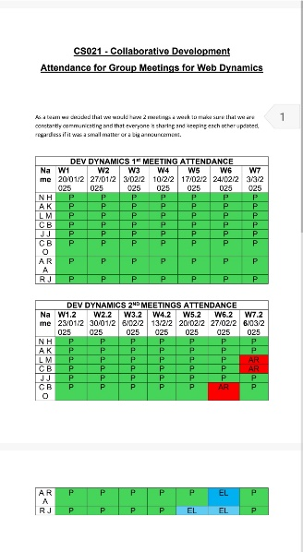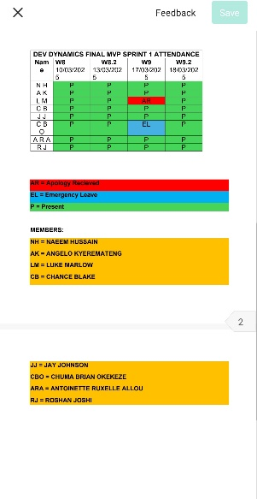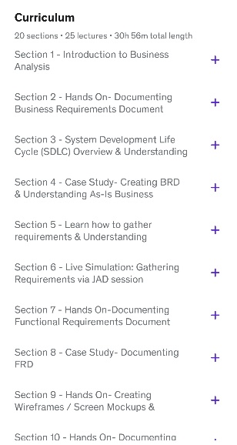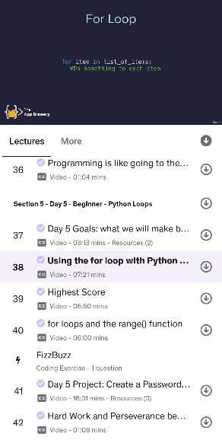
First and second picture: Attendance Sheets
Third Picture: I took some idea from udemy about the role of business analyst
Fourth picture: I learned Python from Udemy to do some coding and I developed heatmap to track searches of places but I could not implemented it because I thought it is not needed for now.

Issue tracking
Receivable evidence includes:
- Screenshots of personal contributions to GitLab issues.
Important: Please include no more than 5 items

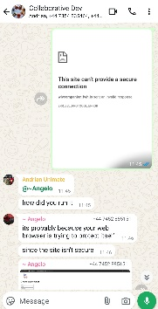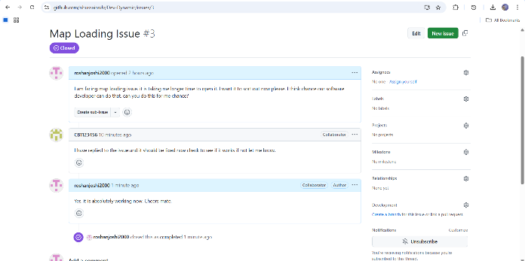
First Picture: Application link was not secure on my device but software developer help me to open it.
Second Picture: I raised issue on github because it was taking me to long time to open the application but again my software developer help me.

Work to deadlines
No evidence required. Your tutor will decide whether you have worked to deadlines based on various factors (team meetings, discussions with other team members, discussion with client etc.)

